**Dataset 1**

**Tasks**

- Cluster the types of crimes based on the success of the police in facing/solving them.

- Cluster the types of crimes and explain what each cluster represents.

- Identify outliers in crime types and explain what they represent/why they are outliers.

- Try to predict the super-category (e.g. ΕΠΙΚΡΑΤΕΙΑ/ΚΛΟΠΕΣ-ΔΙΑΡΡΗΞΕΙΣ, ...) of a record given only its numeric fields (τελ/να, απόπειρες, εξιχνιάσεις, ημεδαποί, αλλοδαποί), providing an explanation of the main factors for the decision and report the performance on a cross-validation evaluation.

**Report**

Before we could begin working on the tasks, the data on the excel had to be transformed. Therefore, columns which belonged to crime super categories, such as "ΚΛΟΠΕΣ - ΔΙΑΡΡΗΞΕΙΣ" etc., were removed from the initial data and "ΕΠΙΚΡΑΤΕΙΑ" was replaced by "ΟΝΟΜΑ ΕΓΚΛΗΜΑΤΟΣ". The super categories were then moved in a new tab named "ΥΠΕΡΚΛΑΣΕΙΣ". Furthermore, all the data around 2015 was also dropped from the dataset.

For the first task we have to cluster the types of crimes based on the success of the police in facing/solving them.

In order to achieve this, we have to keep the columns "τελ/να" and "απόπειρες". The type of clustering that was chosen is Hierarchical clustering since we have few data, and we do not know the number of clusters beforehand.

However, the decision of the number of clusters that can best depict different groups can be chosen by observing the dendrogram. The best choice of the number of clusters is the no. of vertical lines in the dendrogram cut by a horizontal line that can transverse the maximum distance vertically without intersecting a cluster.

For k- means clustering we would need to have prior knowledge about the clusters.

Before applying clustering, we have to normalize the data so that the scale of each variable is the same. Why is this important? If the scale of the variables is not the same, the model might become biased towards the variables with a higher magnitude like ΑΠΑΤΕΣ or ΕΠΑΙΤΕΙΑ.

By observing the notebook – crime.ipynb, we can see that the number of clusters is 2 and that most of the data belonged to the first cluster.

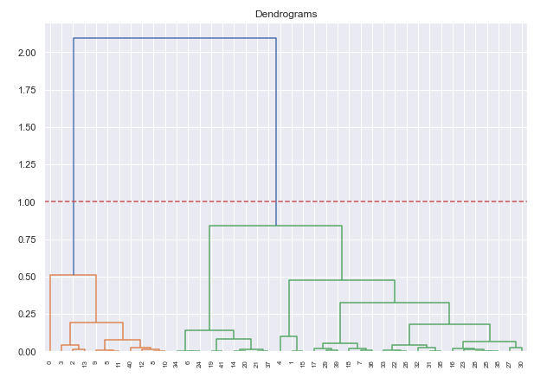

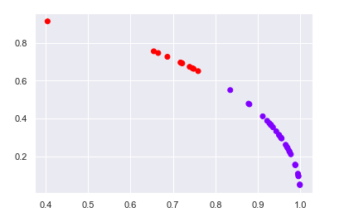

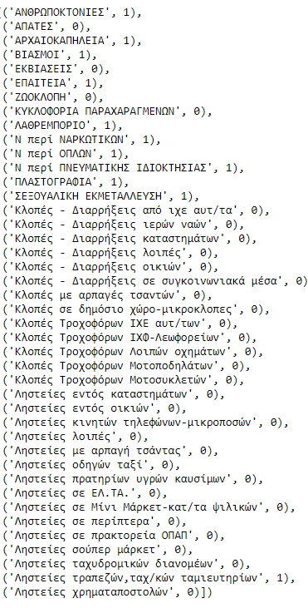

For the second task we have to cluster the types of crimes and explain what each cluster represents. We will use the same algorithm as before but this time we will keep all the columns except for the "ΟΝΟΜΑ ΕΓΚΛΗΜΑΤΟΣ"

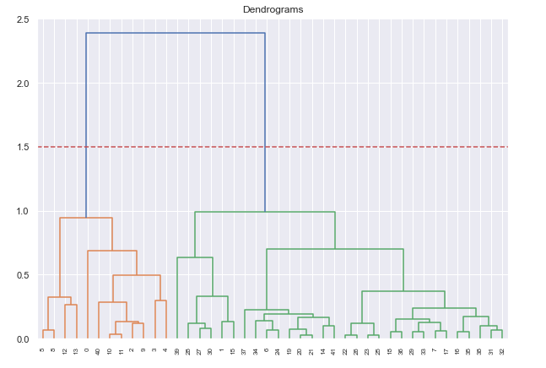

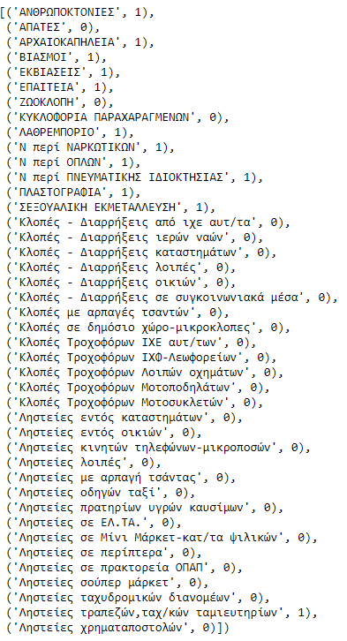

We can now see that the crimes are again divided into 2 clusters. In the one cluster we have all crimes that belong to 'Ληστείες' and 'Κλοπές` as well as some other general crimes while on the other cluster we have the rest of the crimes, with some exceptions.

We used the PCA algorithm, for 3 dimensions, in order to visualize the clusters.

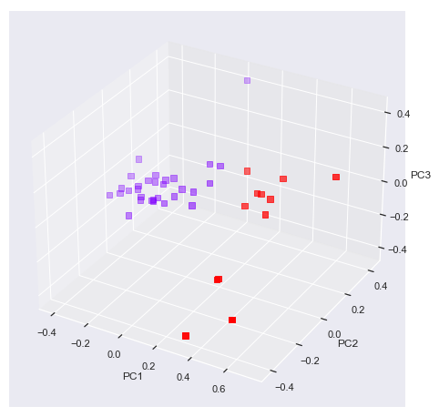

From the schema above we can see that the purple cluster is denser and has few outliers, while the red cluster is sparser with more outliers.

For the third task – the outlier detection, the DBSCAN algorithm was used. In order to find a suitable value for DBSCAN epsilon value did calculate the distance to the nearest n points for each point, sorting and plotting the results. Then we looked to see where the change is most pronounced and select that as epsilon. The epsilon that was chosen was 0.35.

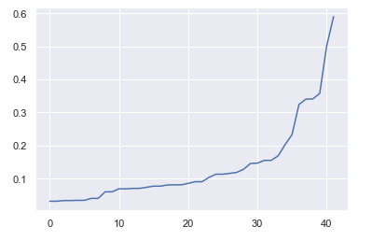

**DBSCAN Results**

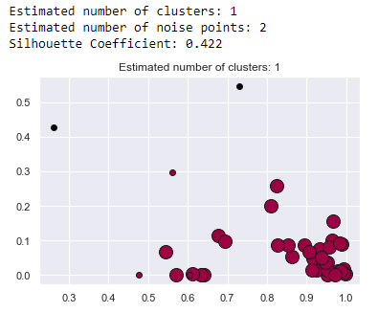

We can see that DBSCAN detects only one possible cluster with a minimum of 5 samples. By observing the cluster, we can also see that it is a bit dense, however some samples are farther than others. Finally, we can only spot 2 outliers in the grid.

**Outliers:**

['ΑΝΘΡΩΠΟΚΤΟΝΙΕΣ', 'Ληστείες ταχυδρομικών διανομέων']

The above data points are outliers. One possible explanation for this could be that the police keep data from previous years as well. For example, a crime could have been committed on a previous year, for example 2014, and it may have been solved on 2016. Therefore, it will be included in the data.

For the last task - predicting the super category of the crimes we will use 4 algorithms: RandomForest, Decision Tree, SVM and KNN, with GridSearch and cross validation, in order to find the best hyperparameters. These algorithms were chosen because they are suitable for classification, especially the ensemble algorithm - RandomForest.

The dataset was split into a train (70%) and a test set (30%).

### **Classification using Random Forest Classifier**

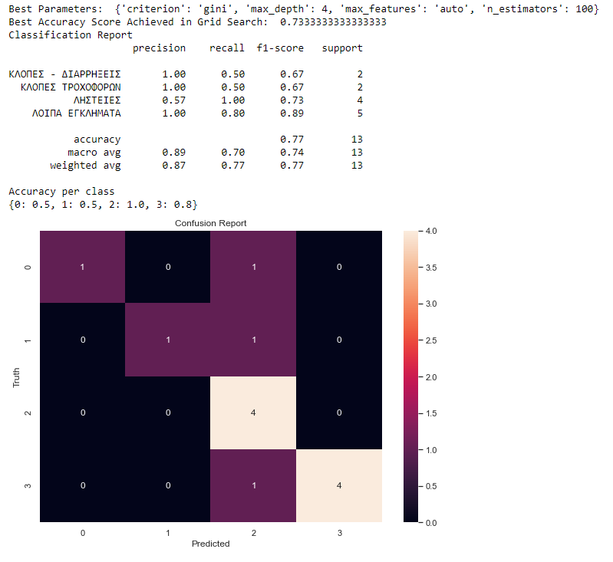

### **Classification using SVM Classifier**

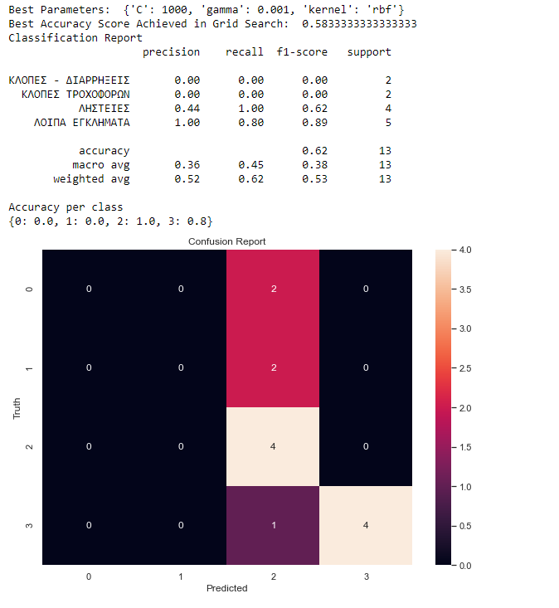

### **Classification using kNN Classifier**

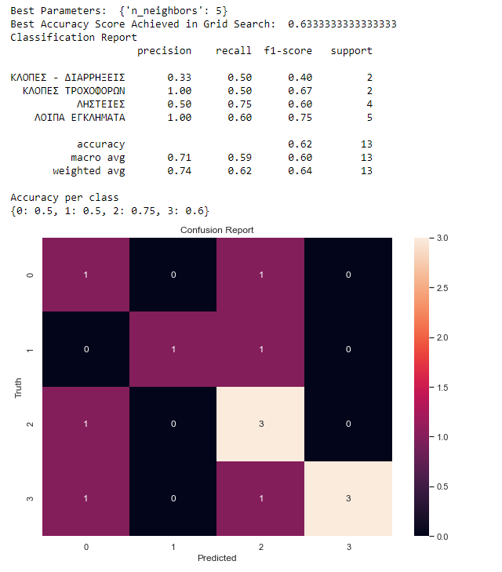

### **Classification using Decision Tree Classifier**

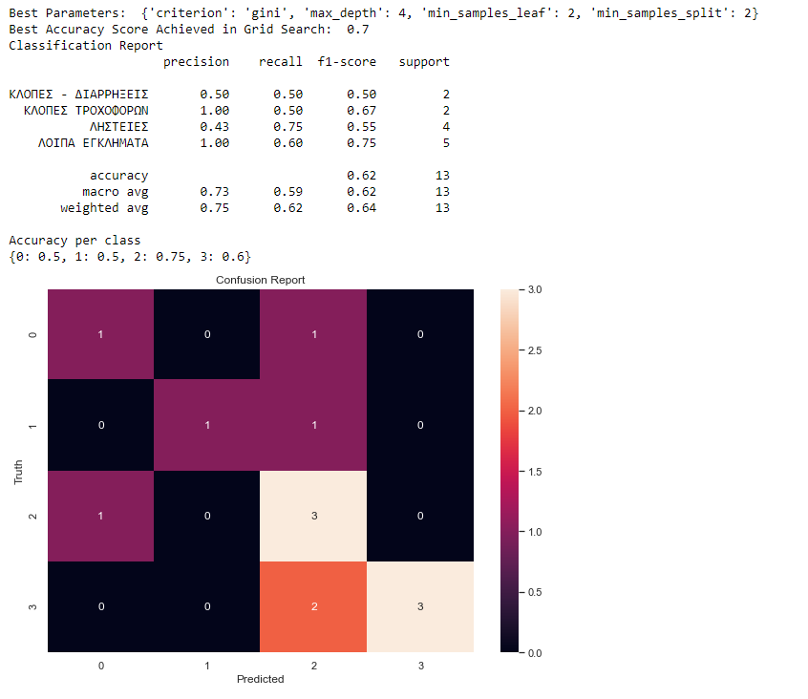

From the above results and the confusion matrices, we can observe that the Random Forest performs better than the rest algorithms.

However, the overall scores are not too high. That makes sense, since the dataset is quite small and contains cumulative information from the past crime years as well.